

WARISAN TC HOLDINGS BERHAD
(Company No: 424834-W)

INTERIM FINANCIAL REPORT FOR THE
QUARTER ENDED 30 JUNE 2006
(THE FIGURES HAVE NOT BEEN AUDITED)

CONDENSED CONSOLIDATED INCOME STATEMENTS

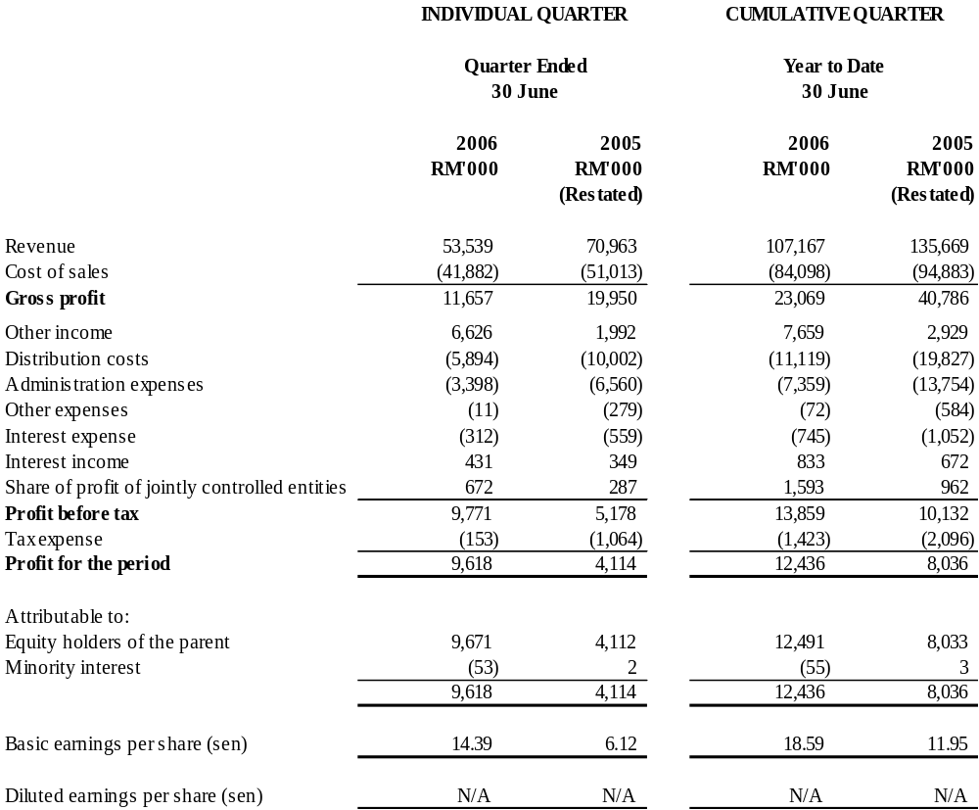

The Condensed Consolidated Income Statements should be read in conjunction with the Annual Financial Statements for
the year ended 31 December 2005.

WARISAN TC HOLDINGS BERHAD
(Company No: 424834-W)

CONDENSED CONSOLIDATED BALANCE SHEETS
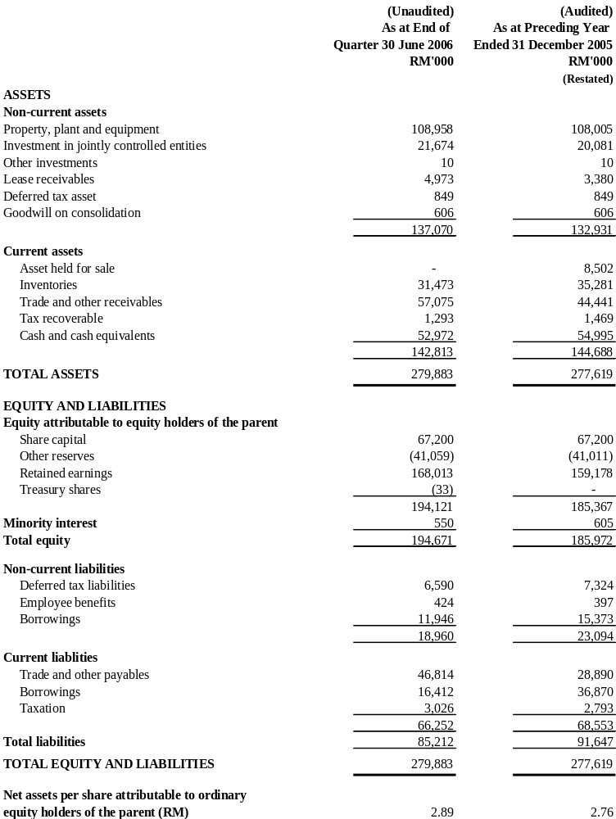

The Condensed Consolidated Balance Sheets should be read in conjunction with the Annual Financial Statements for the year ended 31 December 2005.

WARISAN TC HOLDINGS BERHAD
(Company No: 424834-W)

CONDENSED CONSOLIDATED STATEMENT OF CHANGES IN EQUITY

 |  |  |  | Attributable to Equity Holders of the Parent
 |  |  |  |  |  |  | Non-distributable |  |  | Distributable
 |  |  |  | Share |  | Treasury | Revaluation | Merger | Translation | Retained |  |  | Minority |  | Total
 |  |  |  | Capital |  | Shares | Reserve | Reserve | Reserve | Profit | Total |  | Interest |  | Equity
 |  |  |  | RM'000 |  | RM'000 | RM'000 | RM'000 | RM'000 | RM'000 | RM'000 |  | RM'000 |  | RM'000
As at 1 January 2006 |  |  |  | 67,200 |  | - | 615 | (41,614) | (12) | 159,178 | 185,367 |  | 605 |  | 185,972
Foreign exchange differences arising from translation |  |  |  | - |  | - | - | - | (48) | - | (48) |  | - |  | (48)
Net loss not recognized in the income statement |  |  |  | - |  | - | - | - | (48) | - | (48) |  | - |  | (48)
Purchase of treasury shares |  |  |  | - |  | (33) | - | - | - | - | (33) |  | - |  | (33)
Net profit for the six months period |  |  |  | - |  | - | - | - | - | 12,491 | 12,491 |  | (55) |  | 12,436
Dividend - 2005 final and special |  |  |  | - |  | - | - | - | - | (3,656) | (3,656) |  | - |  | (3,656)
As at 30 June 2006 |  |  |  | 67,200 |  | (33) | 615 | (41,614) | (60) | 168,013 | 194,121 |  | 550 |  | 194,671
As at 1 January 2005 |  |  |  | 67,200 |  | - | 615 | (41,614) | - | 141,218 | 167,419 |  | - |  | 167,419
Investment by minority  shareholders |  |  |  | - |  | - | - | - | - | - | - |  | 600 |  | 600
Net profit for the six months period |  |  |  | - |  | - | - | - | - | 8,033 | 8,033 |  | 3 |  | 8,036
Dividend - 2005 interim |  |  |  | - |  | - | - | - | - | (2,688) | (2,688) |  | - |  | (2,688)
As at 30 June 2005 |  |  |  | 67,200 |  | - | 615 | (41,614) | - | 146,563 | 172,764 |  | 603 |  | 173,367

The Condensed Consolidated Statement of Changes in Equity should be read in conjunction with the Annual Financial Statements for the year ended 31 December 2005.

WARISAN TC HOLDINGS BERHAD
(Company No: 424834-W)

CONDENSED CONSOLIDATED CASH FLOW STATEMENTS

 | For the 6  months ended  30 June 2006 | For the 6  months ended  30 June 2005
 | RM'000 | RM'000
 |  | (Restated)
Profit before tax | 13,859 | 10,132
Adjustments for:
Non-cash items | 2,403 | 7,122
Non-operating items (which are investing/financing) | (88) | 380
Operating profit before working capital changes | 16,174 | 17,634
Working capital changes | 7,505 | (4,536)
Other cash used (tax payment etc.) in operations | (1,787) | (1,910)
Net cash generated from operating activities | 21,892 | 11,188
Net cash generated from/(used in) investing activities
Purchase of property, plant and equipment | (12,484) | (22,734)
Proceeds from disposal of property, plant and  equipment | 16,103 | 4,767
Interest income | 833 | 672
Investment by minority shareholder | - | 600
 | 4,452 | (16,695)
Net cash (used in)/generated from financing activities

Dividends paid to shareholders | (3,656) | -
Purchase of treasury shares | (33) | -
Proceeds from bills payable | 20,170 | 65,525
Repayment of bills payable | (40,658) | (54,862)
Repayment of term loan | (3,397) | (2,770)
Interest expense | (745) | (1,052)
 | (28,319) | 6,841
Net (decrease)/increase in cash and cash equivalents | (1,975) | 1,334
Cash and cash equivalents at beginning of period | 54,995 | 54,210
Foreign exchange differences | (48) | -
Cash and cash equivalents at end of period | 52,972 | 55,544

The Condensed Consolidated Cash Flow Statements should be read in conjunction with the Annual Financial Statements for the year ended 31 December 2005.

Explanatory notes as per MASB 26

- Basis of preparation

The interim financial report is unaudited and has been prepared in accordance with Financial Reporting Standards (“FRS”) 134: Interim Financial Reporting and paragraph 9.22 and Appendix 9B of the Listing Requirements of Bursa Malaysia Securities Berhad. The interim financial report should be read in conjunction with the audited financial statements of the Group for the year ended 31 December 2005.

The accounting policies and methods of computation adopted by the Group in this interim financial report are consistent with those adopted in the financial statements for the year ended 31 December 2005 except for the following new/revised FRS effective for the financial period beginning 1 January 2006:-

FRS3 Business Combinations
FRS5 Non-current Asset Held for Sale and Discontinued Operations
FRS101 Presentation of Financial Statements
FRS102 Inventories
FRS108 Accounting Policies, Changes in Estimates and Errors
FRS110 Events after the Balance Sheet Date
FRS116 Property, Plant and Equipment
FRS121 The effects of Changes in Foreign Exchange Rates
FRS127 Consolidated and Separate Financial Statements
FRS131 Interest in Joint Ventures
FRS132 Financial Instruments : Disclosure and Presentation
FRS133 Earnings Per Share
FRS136 Impairment of Assets
FRS138 Intangible Assets

The adoption of all FRS mentioned above does not have significant financial impact on the Group. A summary of the principal effects on the Group’s accounting policies resulting from the adoption of the new/revised FRS are as follows:-

FRS3 Business Combination
FRS3 requires goodwill acquired in a business combination to be measured at cost and subject to impairment. The Group ceased amortisation of goodwill from 1 January 2006. Goodwill is tested annually for impairment, as well as when there is indication of impairment.

FRS5 Non-current Asset Held for Sale and Discontinued Operations
The Group has identified property, plant and equipment where the carrying amount of the asset will be recovered principally through a sale transaction rather than through continuing use. The asset is reclassified as current asset, ie asset held for sale. The said asset is measured at the lower of its carrying amount and fair value less cost to sell. It ceased to be depreciated from 1 January 2006.

Comparatives

As a result of the adoption of FRS5, comparative figure as of 31 December 2005 has been reclassified as follows:-

 | As previously reported | Reclassification | As restated
 | RM’000 | RM’000 | RM’000
Asset held for sale | - | 8,502 | 8,502

FRS101 Presentation of Financial Statements
The adoption of the revised FRS101 has affected the presentation of minority interest, share of net after tax results of associates and other disclosures. In the consolidated balance sheet, minority interests are now presented within total equity. In the consolidated income statement, minority interests are presented as an allocation of the total profit or loss for the period. A similar requirement is also applicable to the statement of changes in equity. FRS101 also requires disclosure, on the face of the statement of changes in equity, total recognized income and expenses for the period, showing separately the amounts attributable to equity holders of the parent and to minority interest.

The current period’s presentation of the Group’s financial statements is based on the revised requirements of FRS101, with the comparatives restated to conform with current period’s presentation.

As of the date of this interim financial report, the Group has not adopted the following three new standards which have been issued by the Malaysian Accounting Standards Board but not yet effective:-

FRS117 Leases
FRS124 Related Party Disclosures
FRS139 Financial Instruments: Recognition and Measurement

The Group will apply these new standards for the period commencing 1 January 2007, when they become effective. While there may be changes to the presentation of the Group’s financial statements and additional disclosures made, it is expected that there will be no material impact on the Income Statement when the Group applies these new accounting standards.

- Qualification of financial statements

The audited report of the preceding annual financial statements was not subject to any qualification.

- Seasonal or cyclical factors

Apart from the general economic environment in which the Group operates, the businesses of the Group were not affected by any significant seasonal or cyclical factors in the current interim period.

- Nature and amount of unusual items

There were no unusual items that have a material effect on the assets, liabilities, equity, net income, or cash flows for the current interim period.

- Nature and amount of changes in estimates

There were no material changes in estimates in respect of amounts reported in prior interim periods of the prior financial year.

- Debt and equity securities

On 17 May 2006, the shareholders of the Company gave approval for the Company to repurchase its own ordinary shares. During the current interim period, the Company repurchased 20,000 of its issued ordinary shares from the open market at an average price of RM1.66 per share. Total consideration paid for the repurchase including transaction costs was RM33,155 and this was financed by internally generated funds. The shares repurchased are being held as treasury shares in accordance with Section 67A of the Companies Act 1965. None of the treasury shares held were resold or cancelled during the current interim period.

There were no issuance and repayment of debt securities, share cancellation and resale of treasury shares for the current interim period.

- Dividends paid

At the Annual General Meeting held on 17 May 2006, the shareholders of the Company approved the payment of a final dividend of 4% (2004-4%) tax exempt per share and a special dividend of 2% (2004-nil) less tax per share for the financial year ended 31 December 2005. The total amount of RM3,655,680 was paid on 22 June 2006.

- Segmental reporting

The Group’s segmental report for the financial year-to-date is as follows:-
Business segments | Consumer  Products  (Restated) |  | Travel and  Car Rental (Restated) |  | Machinery |  | Other  Operations  (Restated) |  | Elimination |  | Consolidated  (Restated)
Business segments | 2006  RM’000 | 2005  RM’000 | 2006  RM’000 | 2005  RM’000 | 2006  RM’000 | 2005  RM’000 | 2006  RM’000 | 2005  RM’000 | 2006  RM’000 | 2005  RM’000 | 2006  RM’000 | 2005  RM’000
Revenue - external | 794 | 30,262 | 54,758 | 43,307 | 51,025 | 61,553 | 590 | 547 | - | - | 107,167 | 135,669
Inter-segment revenue | - | - | 45 | 36 | - | - | - | - | (45) | (36) | - | -
Total revenue | 794 | 30,262 | 54,803 | 43,343 | 51,025 | 61,553 | 590 | 547 | (45) | (36) | 107,167 | 135,669
Segment result | 7,018 | 2,452 | 2,346 | 2,034 | 3,852 | 5,624 | 242 | 443 | - | - | 13,458 | 10,553
Unallocated expenses |  |  |  |  |  |  |  |  |  |  | (1,280) | (1,003)
Interest expense |  |  |  |  |  |  |  |  |  |  | (745) | (1,052)
Interest income |  |  |  |  |  |  |  |  |  |  | 833 | 672
Share of profit of jointly controlled entities | 841 | 403 | 752 | 559 | - | - | - | - | - | - | 1,593 | 962
Profit before tax |  |  |  |  |  |  |  |  |  |  | 13,859 | 10,132

- Property, Plant and Equipment

The valuation of property, plant and equipment were brought forward without amendment from the annual financial statements for the year ended 31 December 2005.

- Material subsequent event

Save as disclosed below, there has not arisen in the interval between the end of this reporting period and the date of this announcement, any item, transaction or event of a material and unusual nature likely to affect substantially the results of the operations of the Group:-

On 3 August 2006, the Company incorporated a wholly-owned subsidiary namely Mayflower (Labuan) Pte Ltd to cater for the Group’s future business expansion needs.

- Changes in composition of the Group

On 4 April 2006, a new wholly-owned subsidiary of the Company namely Excess Line Sdn Bhd was incorporated with an authorized share capital of RM100,000 and issued and paid up capital of RM2 to carry on the business as a licensed money changer.

- Changes in contingent liabilities

There were no material changes in contingent liabilities since the last quarterly announcement made except as disclosed in note 11 under the additional information required by Bursa Malaysia Securities Berhad (“BMSB”)’s Listing Requirements.

Additional Information Required by the BMSB’s Listing Requirements

- Review of performance

For the six months period, Group revenue decreased by 21% to RM107.2 million compared to RM135.7 million of the corresponding period. The decrease was due mainly to the non-consolidation of a 50% owned jointly-controlled entity which is currently the distributor of Shiseido products. Group profit before tax of RM13.9 million was 38% higher than the corresponding period of RM10.1 million. The increase in profit before tax was largely due to gain on disposal of property amounting to RM5.7 million.

The machinery division recorded a decrease in revenue and profitability of 17% and 33% respectively compared to the corresponding period. The unfavourable performance was generally due to lower demand in equipment.

The travel and car rental division recorded an increase in revenue of 26% compared to the corresponding period due to overall improvement in revenue of the three main business streams, i.e. inbound, outbound and car rental. Profitability increased by 18% compared to the corresponding period, contributed mainly by inbound and air ticketing businesses as a result of higher sales achieved.

As for the consumer products division, revenue was lower than the corresponding period. The decrease was due to the non-consolidation of a 50% owned jointly-controlled entity which is currently the distributor of Shiseido products. Prior to 1 October 2005, the distribution of Shiseido products was carried out by a subsidiary of the Company. Consequently, profitability (excluding gain on disposal of property amounting to RM5.7 million) was 10% lower compared to the corresponding period. The decrease was however partly offset by the increased and additional contribution from the joint venture companies, namely Wacoal Malaysia Sdn Bhd and Shiseido Malaysia Sdn Bhd respectively.

- Comparison with preceding quarter’s results

Group revenue of RM53.5 million in the current quarter was consistent with the immediate preceding quarter of RM53.6 million while group profit before tax of RM9.8 million was 139% higher than the immediate preceding quarter of RM4.1 million. The increase in profitability was due to gain on disposal of property amounting to RM5.7 million.

- Current year prospects

The tourism industry is expected to grow but faced with stiff competition while market sentiment for machinery and consumer products divisions remains volatile. Barring any unforeseen circumstances, the Group performance is expected to be satisfactory.

- Profit forecast

This is not applicable to the Group.

- Taxation
 |  | Individual Quarter |  |  |  | Cumulative Quarter
 |  | 30.06.06 |  | 30.06.05 |  | 30.06.06 |  | 30.06.05
 |  | RM’000 |  | RM’000 |  | RM’000 |  | RM’000
 |  |  |  | (Restated) |  |  |  | (Restated)
Current tax expense
Current |  | 1,103 |  | 948 |  | 1,901 |  | 1,993
Under provision in prior year |  | - |  | 116 |  | 256 |  | 103
Deferred tax expense
Current |  | (950) |  | - |  | (800) |  | -
Under provision in prior year |  | - |  | - |  | 66 |  | -
 |  | 153 |  | 1,064 |  | 1,423 |  | 2,096

The Group’s current effective tax rate for 2006 and 2005 is lower than the prima facie tax rate due mainly to utilisation of capital allowances arising from purchases of fixed assets and the tax exempt status of certain sources of income which is specific to the travel industry.

There was crystallization of deferred tax amounting to RM1,450,020 in the current interim period following the disposal of a property by a subsidiary of the Company.

- Profit on sale of unquoted investments and/or properties

There were no sale of unquoted investments and properties during the current interim period except for the disposal of property by Tung Pao Sdn Bhd (a wholly-owned subsidiary of the Company) to Tan Chong & Sons Motor Company Sdn Bhd (a wholly-owned subsidiary of Tan Chong Motor Holdings Berhad) for a total cash consideration of RM14.2 million. The said disposal was completed on 2 May 2006 and gave rise to a net gain of approximately RM5.7 million.

- Purchase or disposal of quoted securities

There was no purchase or disposal of quoted securities for the current interim period.

- Status of corporate proposals

Following the signing of the Memorandum of Understanding between the Company and China First Automobile Group Import & Export Corporation (“FAW”) for the appointment of Angka-Tan Machinery Sdn Bhd (“ATM”), a wholly-owned subsidiary, as an assembler, distributor and after-sales provider of FAW products on 30 June 2005, the Group has submitted an application to the Ministry of International Trade and Industry (“MITI”) for import permit in relation to the proposed FAW truck business. MITI has written to ATM for additional information and the management is looking into the matter.

- Group borrowings

Particulars of the Group borrowings as at reporting date are as follows:

Current |  |  | Unsecured  RM'000
Bills payable |  |  | 9,572
Term loan |  |  | 6,840
 |  |  | 16,412
Non-current
Term loan |  |  | 11,946

The above borrowings were denominated in Ringgit Malaysia.

- Off balance sheet financial instruments

The Group does not have any financial instrument with off balance sheet risk as at the cut-off date of 9 August 2006 apart from outstanding forward contracts on foreign currencies in relation to the Group’s purchases, the impact of which will be reflected in the operating performance of the Group.

Currency | Contract Amount  (‘000) | Equivalent amount in  Ringgit Malaysia (‘000) | Expiry date
Japanese Yen | 470,766 | 15,275 | 15.08.06-30.11.06
Euro | 196 | 909 | 11.08.06-29.12.06
US Dollar | 493 | 1,791 | 30.08.06-29.09.06

Forward foreign exchange contracts are entered into with licensed banks to immunise certain portion of the Group’s purchases from exchange rate movements. As the exchange rates are pre-determined under such contracts, the Company is not exposed to any market risk. Given that the contracts are entered into with licensed banks, we are of the view that credit risk is minimal. Apart from a small fee payable to the banks, there is no cash requirement for these contracts.

As the forward contracts are short term in nature, no adjustment has been made at the balance sheet date to account for the difference between the contracted rate and the prevailing market rate.

- Material litigation

On 3 July 2002, the Company and a subsidiary have claimed for damages against two former directors of the subsidiary for breaches of their fiduciary and/or contractual duties. On or about 25 June 2004, two ex-employees of subsidiaries of the Company were added as defendants to the action.

On 6 August 2002, one of the defendants has brought a derivative action, by way of counterclaim, for the benefit of the Company, claiming damages against certain current and former directors of the Company for alleged breaches of their fiduciary duties to the Company. The said counterclaim was struck out by the SAR on 20 October 2003. The said defendant has filed an appeal to the Judge in Chambers. The appeal was dismissed with costs by the Judge on 2 April 2004. An appeal to the Court of Appeal is pending.

On 7 February 2006, the plaintiffs have filed an application for leave to include another party as co-defendant. The application was allowed by the Registrar on 2 August 2006. The first and second defendants have filed an appeal against that decision to the Judge in Chambers; but no hearing date has been fixed.

12. Dividend

The Board of Directors is pleased to declare an interim dividend of 4% less tax (2005 – 3% tax exempt) per share for the financial year ending 31 December 2006. The interim dividend will be paid on 2 October 2006.

The entitlement date for the interim dividend shall be 7 September 2006. A depositor shall qualify for entitlement to the dividend only in respect of:

- shares transferred into the depositor’s securities account before 4:00 p.m. on 7 September 2006 in respect of ordinary transfers;
- shares deposited into the depositor’s securities account before 12:30 p.m. on 5 September 2006 in respect of shares exempted from mandatory deposit; and
- shares bought on Bursa Malaysia Securities Berhad on a cum-entitlement basis in accordance with the rules of Bursa Malaysia Securities Berhad.

13. Earnings per share

Basic earnings per share is calculated based on profit for the period attributable to ordinary equity holders and weighted average number of ordinary shares in issue during the period.

 |  | Individual Quarter |  |  |  | Cumulative Quarter
 |  | 30.06.06 |  | 30.06.05 |  | 30.06.06 |  | 30.06.05
 |  | RM’000 |  | RM’000 |  | RM’000 |  | RM’000
Profit attributable to ordinary equity
holders of the Company |  | 9,671 |  | 4,112 |  | 12,491 |  | 8,033

 |  | Individual Quarter |  |  |  | Cumulative Quarter
 |  | 30.06.06 |  | 30.06.05 |  | 30.06.06 |  | 30.06.05
 |  | ’000 |  | ’000 |  | ’000 |  | ’000
Weighted average number of
ordinary shares in issue |  | 67,192 |  | 67,200 |  | 67,196 |  | 67,200

 |  | Individual Quarter |  |  |  | Cumulative Quarter
 |  | 30.06.06 |  | 30.06.05 |  | 30.06.06 |  | 30.06.05
 |  | Sen |  | Sen |  | Sen |  | Sen
Basic earnings per share |  | 14.39 |  | 6.12 |  | 18.59 |  | 11.95

BY ORDER OF THE BOARD
CHAN YOKE LIN
Company Secretary
Kuala Lumpur
16 August 2006

