

WARISAN TC HOLDINGS BERHAD
(Company No: 424834-W)

INTERIM FINANCIAL REPORT FOR THE
QUARTER ENDED 31 MARCH 2006
(THE FIGURES HAVE NOT BEEN AUDITED)

CONDENSED CONSOLIDATED INCOME STATEMENTS

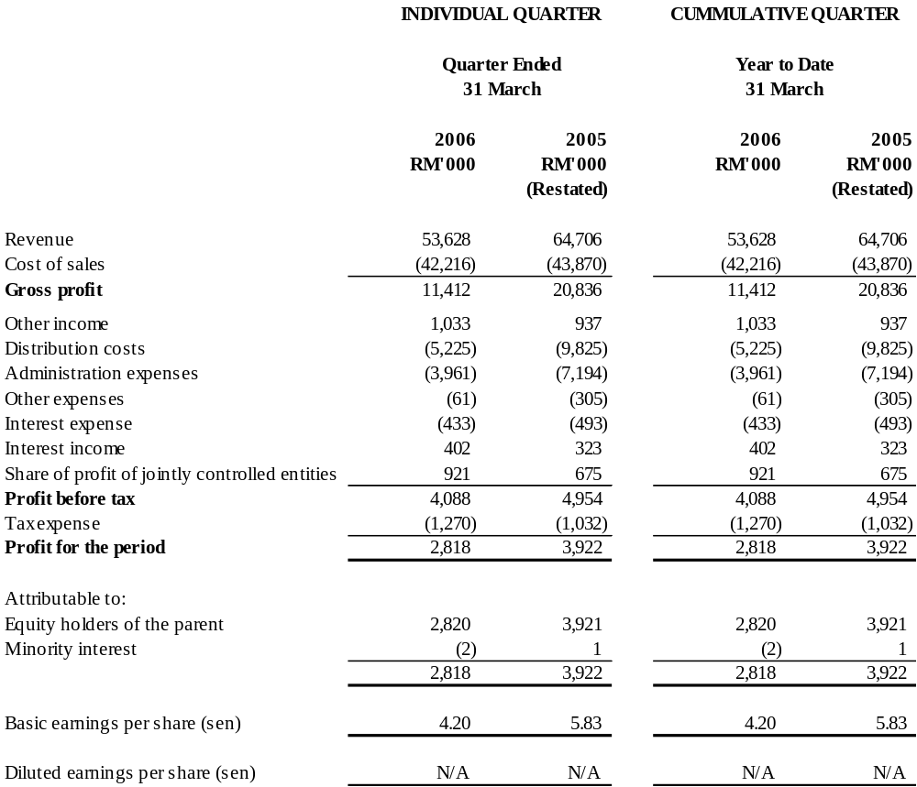

The Condensed Consolidated Income Statements should be read in conjunction with the Annual Financial Statements
for the year ended 31 December 2005.

WARISAN TC HOLDINGS BERHAD
(Company No: 424834-W)

CONDENSED CONSOLIDATED BALANCE SHEETS

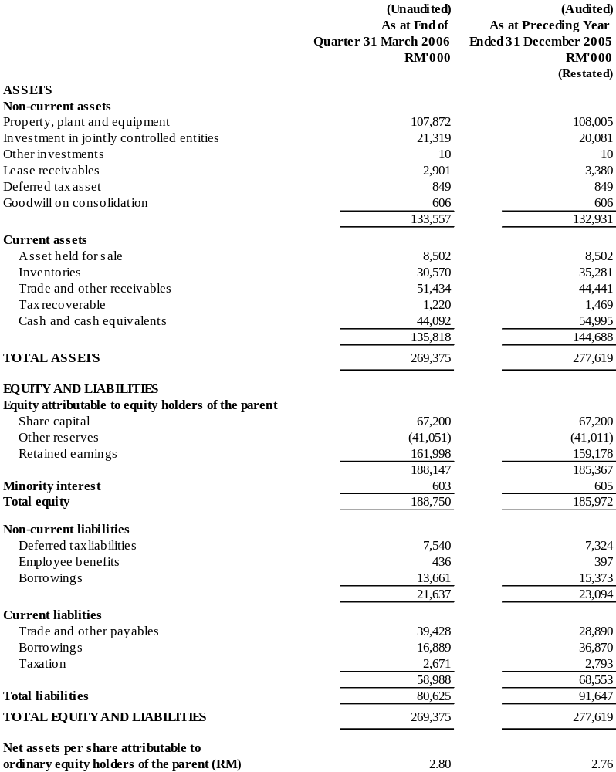
The Condensed Consolidated Balance Sheets should be read in conjunction with the Annual Financial Statements for the year ended 31 December 2005.

WARISAN TC HOLDINGS BERHAD
(Company No: 424834-W)

CONDENSED CONSOLIDATED STATEMENT OF CHANGES IN EQUITY

 |  |  | Attributable to Equity Holders of the Parent
 |  |  |  | Non-distributable |  |  | Distributable
 |  |  | Share | Revaluation | Merger | Translation | Retained |  | Minority | Total
 |  |  | Capital | Reserve | Reserve | Reserve | Profit | Total | Interest | Equity
 |  |  | RM'000 | RM'000 | RM'000 | RM'000 | RM'000 | RM'000 | RM'000 | RM'000
As at 1 January 2006 |  |  | 67,200 | 615 | (41,614) | (12) | 159,178 | 185,367 | 605 | 185,972
Foreign exchange differences arising from translation |  |  | - | - | - | (40) | - | (40) | - | (40)
Net loss not recognised in the income statement |  |  | - | - | - | (40) | - | (40) | - | (40)
Net profit/(loss) for the three months period |  |  | - | - | - | - | 2,820 | 2,820 | (2) | 2,818
As at 31 March 2006 |  |  | 67,200 | 615 | (41,614) | (52) | 161,998 | 188,147 | 603 | 188,750
As at 1 January 2005 |  |  | 67,200 | 615 | (41,614) | - | 141,218 | 167,419 | - | 167,419
Investment by minority shareholder |  |  | - | - | - | - | - | - | 600 | 600
Net profit for the three months period |  |  | - | - | - | - | 3,921 | 3,921 | 1 | 3,922
As at 31 March 2005 |  |  | 67,200 | 615 | (41,614) | - | 145,139 | 171,340 | 601 | 171,941

The Condensed Consolidated Statement of Changes in Equity should be read in conjunction with the Annual Financial Statements for the year ended 31 December 2005.

WARISAN TC HOLDINGS BERHAD
(Company No: 424834-W)

CONDENSED CONSOLIDATED CASH FLOW STATEMENTS

 | For the 3  months ended  31 March 2006 | For the 3  months ended  31 March 2005
 | RM'000 | RM'000
 |  | (Restated)
Profit before tax | 4,088 | 4,954
Adjustments for:
Non-cash items | 3,827 | 3,524
Non-operating items (which are investing/financing) | 31 | 170
Operating profit before working capital changes | 7,946 | 8,648
Working capital changes | 8,418 | (5,574)
Other cash used (tax payment etc.) in operations | (954) | (680)
Net cash generated from operating activities | 15,410 | 2,394
Net cash used in investing activities
Purchase of property, plant and equipment | (5,197) | (7,629)
Proceeds from disposal of property, plant and  equipment | 648 | 1,766
Interest income | 402 | 323
 | (4,147) | (5,540)
Net cash (used in)/generated from financing activities

Proceeds from bills payable | 11,737 | 29,996
Repayment of bills payable | (31,733) | (21,000)
Repayment of term loan | (1,697) | (1,384)
Interest expense | (433) | (493)
 | (22,126) | 7,119
Net (decrease)/increase in cash and cash equivalents | (10,863) | 3,973
Cash and cash equivalents at beginning of period | 54,995 | 54,210
Foreign exchange differences | (40) | -
Cash and cash equivalents at end of period | 44,092 | 58,183

The Condensed Consolidated Cash Flow Statements should be read in conjunction with the Annual Financial
Statements for the year ended 31 December 2005.

Explanatory notes as per MASB 26

- Basis of preparation

The interim financial report is unaudited and has been prepared in accordance with Financial Reporting Standards (“FRS”) 134: Interim Financial Reporting and paragraph 9.22 and Appendix 9B of the Listing Requirements of Bursa Malaysia Securities Berhad. The interim financial report should be read in conjunction with the audited financial statements of the Group for the year ended 31 December 2005.

The accounting policies and methods of computation adopted by the Group in this interim financial report are consistent with those adopted in the financial statements for the year ended 31 December 2005 except for the following new/revised FRS effective for the financial period beginning 1 January 2006:-

FRS3 Business Combinations
FRS5 Non-current Asset Held for Sale and Discontinued Operations
FRS101 Presentation of Financial Statements
FRS102 Inventories
FRS108 Accounting Policies, Changes in Estimates and Errors
FRS110 Events after the Balance Sheet Date
FRS116 Property, Plant and Equipment
FRS121 The effects of Changes in Foreign Exchange Rates
FRS127 Consolidated and Separate Financial Statements
FRS131 Interest in Joint Ventures
FRS132 Financial Instruments : Disclosure and Presentation
FRS133 Earnings Per Share
FRS136 Impairment of Assets
FRS138 Intangible Assets

The adoption of all FRS mentioned above does not have significant financial impact on the Group. A summary of the principal effects on the Group’s accounting policies resulting from the adoption of the new/revised FRS are as follows:-

FRS3 Business Combination
FRS3 requires goodwill acquired in a business combination to be measured at cost and subject to impairment. The Group ceased amortisation of goodwill from 1 January 2006. Goodwill is tested annually for impairment, as well as when there is indication of impairment.

FRS5 Non-current Asset Held for Sale and Discontinued Operations
The Group has identified property, plant and equipment where the carrying amount of the asset will be recovered principally through a sale transaction rather than through continuing use. The asset is reclassified as current asset, ie asset held for sale. The said asset is measured at the lower of its carrying amount and fair value less cost to sell. It ceased to be depreciated from 1 January 2006.

Comparatives

As a result of the adoption of FRS5, comparative figure as of 31 December 2005 has been reclassified as follows:-

 | As previously reported | Reclassification | As restated
 | RM’000 | RM’000 | RM’000
Asset held for sale | - | 8,502 | 8,502

FRS101 Presentation of Financial Statements
The adoption of the revised FRS101 has affected the presentation of minority interest, share of net after tax results of associates and other disclosures. In the consolidated balance sheet, minority interests are now presented within total equity. In the consolidated income statement, minority interests are presented as an allocation of the total profit or loss for the period. A similar requirement is also applicable to the statement of changes in equity. FRS101 also requires disclosure, on the face of the statement of changes in equity, total recognized income and expenses for the period, showing separately the amounts attributable to equity holders of the parent and to minority interest.

The current period’s presentation of the Group’s financial statements is based on the revised requirements of FRS101, with the comparatives restated to conform with current period’s presentation.

As of the date of this interim financial report, the Group has not adopted the following three new standards which have been issued by the Malaysian Accounting Standards Board and are not yet effective:-

FRS117 Leases
FRS124 Related Party Disclosures
FRS139 Financial Instruments: Recognition and Measurement

The Group will apply these new standards for the period commencing 1 January 2007, when they become effective. While there may be changes to the presentation of the Group’s financial statements and additional disclosures made, it is expected that there will be no material impact on the Income Statement when the Group applies these new accounting standards.

- Qualification of financial statements

The audited report of the preceding annual financial statements was not subject to any qualification.

- Seasonal or cyclical factors

Apart from the general economic environment in which the Group operates, the businesses of the Group were not affected by any significant seasonal or cyclical factors in the current interim period.

- Nature and amount of unusual items

There were no unusual items that have a material effect on the assets, liabilities, equity, net income, or cash flows for the current interim period.

- Nature and amount of changes in estimates

There were no material changes in estimates in respect of amounts reported in prior interim periods of the prior financial year.

- Debt and equity securities

There were no issuance and repayment of debt and equity securities, share buy-back, share cancellation and resale of treasury shares for the current interim period.

- Dividends paid

No dividend has been declared or paid in the current interim period.

- Segmental reporting

The Group’s segmental report for the financial year-to-date is as follows:-

Business Segments | Consumer  Products  (Restated) |  | Travel and  Car Rental |  | Machinery |  | Other  Operations  (Restated) |  | Elimination |  | Consolidated  (Restated)
Business Segments | 2006  RM’000 | 2005  RM’000 | 2006  RM’000 | 2005  RM’000 | 2006  RM’000 | 2005  RM’000 | 2006  RM’000 | 2005  RM’000 | 2006  RM’000 | 2005  RM’000 | 2006  RM’000 | 2005  RM’000
Revenue - external | 327 | 16,100 | 26,736 | 19,159 | 26,283 | 29,168 | 282 | 279 | - | - | 53,628 | 64,706
Inter-segment revenue | - | - | 26 | 28 | - | - | - | - | (26) | (28) | - | -
Total revenue | 327 | 16,100 | 26,762 | 19,187 | 26,283 | 29,168 | 282 | 279 | (26) | (28) | 53,628 | 64,706
Segment result | 692 | 1,230 | 1,276 | 1,004 | 1,847 | 2,503 | 148 | 196 | - | - | 3,963 | 4,933
Unallocated expenses |  |  |  |  |  |  |  |  |  |  | (765) | (484)
Interest expense |  |  |  |  |  |  |  |  |  |  | (433) | (493)
Interest income |  |  |  |  |  |  |  |  |  |  | 402 | 323
Share of profit of jointly controlled entities | 604 | 483 | 317 | 192 |  |  |  |  |  |  | 921 | 675
Profit before tax |  |  |  |  |  |  |  |  |  |  | 4,088 | 4,954

- Property, Plant and Equipment

The valuation of property, plant and equipment were brought forward without amendment from the annual financial statements for the year ended 31 December 2005.

- Material subsequent event

Further to the announcement made on 24 February 2006, the disposal of a property by Tung Pao Sdn Bhd (a wholly owned subsidiary of the Company) to Tan Chong & Sons Motor Company Sdn Bhd (a wholly owned subsidiary of Tan Chong Motor Holdings Berhad) for a cash consideration of RM14.2 million was completed on 2 May 2006.

- Changes in composition of the Group

There was no change in composition of the Group for the current interim period.

On 4 April 2006, a new wholly-owned subsidiary of the Company named Excess Line Sdn Bhd was incorporated with an authorized share capital of RM100,000 and issued and paid up capital of RM2 to carry on the business as a licensed money changer.

- Changes in contingent liabilities

There were no material changes in contingent liabilities since the last quarterly announcement made except as disclosed in note 11 under the additional information required by Bursa Malaysia Securities Berhad (“BMSB”)’s Listing Requirements

Additional Information Required by the BMSB’s Listing Requirements

- Review of performance

The machinery division recorded a decrease in both revenue and profit compared to the corresponding quarter. The said unfavourable performance was due mainly to lower sales achieved in the forklift sector coupled with erosion of its gross profit margin.

Revenue of the travel and car rental division increased by approximately 40% compared to the corresponding quarter due mainly to the overall improvement in revenue of the three main business streams, ie inbound, outbound and car rental. Profit was recorded 27% higher mainly attributed to the following reasons:-

- increased revenue of inbound and car rental businesses;
- improved gross profit margin of inbound business.

As for the consumer products division, revenue was lower than the corresponding quarter. The decrease was due to the non-consolidation of a 50% owned jointly controlled entity which is currently the distributor of Shiseido products. Prior to 1 October 2005, the distribution of Shiseido products was carried out by a subsidiary of the Company. Consequently, profit was also lower compared to the corresponding quarter due to the cessation of business of the said subsidiary.

During the quarter, a subsidiary of the Company named Hairbiz College of Hairdressing Professionals Sdn Bhd (formerly known as TC Beauty Services Sdn Bhd) commenced a new business as a hairdressing college.

- Comparison with preceding quarter’s results

Group revenue increased by 18% to RM53.6 million against the immediate preceding quarter of RM45.5 million whilst group profit before tax of RM4.1 million was 52% lower than the immediate preceding quarter of RM8.6 million. The increase in revenue was contributed by the travel and car rental division. In terms of profitability, the decrease was due to the gain on disposal of the Shiseido business amounting to RM4.8 million recognized in the preceding quarter.

- Current year prospects

The tourism industry is expected to grow while market sentiment for machinery and consumer products divisions remains volatile. Barring any unforeseen circumstances, the Group performance is expected to be satisfactory.

- Profit forecast

This is not applicable to the Group.

- Taxation
 |  | Individual Quarter |  |  |  | Cumulative Quarter
 |  | 31.03.06 |  | 31.03.05 |  | 31.03.06 |  | 31.03.05
 |  | RM’000 |  | RM’000 |  | RM’000 |  | RM’000
 |  |  |  | (Restated) |  |  |  | (Restated)
Current tax expense
Current |  | 798 |  | 1,045 |  | 798 |  | 1,045
Under/(over) provision in prior year |  | 256 |  | (13) |  | 256 |  | (13)
Deferred tax expense
Current |  | 150 |  | - |  | 150 |  | -
Under provision in prior year |  | 66 |  | - |  | 66 |  | -
 |  | 1,270 |  | 1,032 |  | 1,270 |  | 1,032

The Group’s current effective tax rate for 2006 and 2005 is lower than the prima facie tax rate due mainly to utilisation of capital allowances arising from purchases of fixed assets and the tax exempt status of certain sources of income which is specific to the travel industry.

- Profit on sale of unquoted investments and/or properties

There was no sale of unquoted investments and/or properties during the current interim period.

- Purchase or disposal of quoted securities

There was no purchase or disposal of quoted securities for the current interim period.

- Status of corporate proposals

Following the signing of the Memorandum of Understanding between the Company and China First Automobile Group Import & Export Corporation (“FAW”) for the appointment of Angka-Tan Machinery Sdn Bhd, a wholly-owned subsidiary, as an assembler, distributor and after-sales provider of FAW products on 30 June 2005, the Group has submitted an application to the Ministry of International Trade and Industry (“MITI”) for import permit in relation to the proposed FAW truck business. The Company is awaiting a reply from MITI.

- Group borrowings

Particulars of the Group borrowings as at reporting date are as follows:

Current |  |  | Unsecured  RM'000
Bills payable |  |  | 10,064
Term loan |  |  | 6,825
 |  |  | 16,889
Non current
Term loan |  |  | 13,661

The above borrowings were denominated in Ringgit Malaysia.

- Off balance sheet financial instruments

The Group does not have any financial instrument with off balance sheet risk as at the cut-off date of 17 May 2006 apart from outstanding forward contracts on foreign currencies in relation to the Group’s purchases, the impact of which will be reflected in the operating performance of the Group.

Currency | Contract Amounts (‘000) | Equivalent amount in  Ringgit Malaysia (‘000) | Expiry dates
Japanese Yen | 286,307 | 9,135 | 31.5.06-31.7.06
Euro | 170 | 773 | 29.6.06-28.7.06
US Dollar | 650 | 2,333 | 5.6.06-3.10.06

Forward foreign exchange contracts are entered into with licensed banks to immunise certain portion of the Group’s purchases from exchange rate movements. As the exchange rates are pre-determined under such contracts, the company is

not exposed to any market risk. Given that the contracts are entered into with licensed banks, we are of the view that credit risk is minimal. Apart from a small fee payable to the banks, there is no cash requirement for these contracts.

As the forward contracts are short term in nature, no adjustment has been made at the balance sheet date to account for the difference between the contracted rate and the prevailing market rate.

- Material litigation.

On 3 July 2002, the Company and a subsidiary have claimed for damages against two former directors of the subsidiary for breaches of their fiduciary and/or contractual duties. On or about 25 June 2004, two ex-employees of subsidiaries of the Company were added as defendants to the action.

On 6 August 2002, one of the defendants has brought a derivative action, by way of counterclaim, for the benefit of the Company, claiming damages against certain current and former directors of the Company for alleged breaches of their fiduciary duties to the Company. The said counterclaim was struck out by the SAR on 20 October 2003. The said defendant has filed an appeal to the Judge in Chambers. The appeal was dismissed with costs by the Judge on 2 April 2004. An appeal to the Court of Appeal is pending.

On 7 February 2006, the plaintiffs have filed an application for leave to include another party as co-defendant. The application is fixed for hearing before the Registrar on 7 June 2006.

12. Dividend

The shareholders of the Company have, at the Annual General Meeting held on 17 May 2006, approved the payment of a final dividend of 4% (2004-4%) tax exempt per share and a special dividend of 2% (2004-nil) less tax per share for the financial year ended 31 December 2005. The total amount payable of RM3,655,680 will be paid on 22 June 2006.

13. Earnings per share (“EPS”)

The EPS for the current interim period was calculated based on the net profit divided by 67.2 million ordinary shares. There were no changes in the number of ordinary shares during the period.

BY ORDER OF THE BOARD
CHAN YOKE LIN
Company Secretary
Kuala Lumpur
24 May 2006

